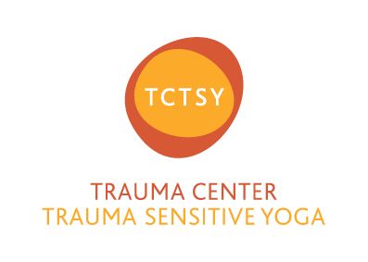
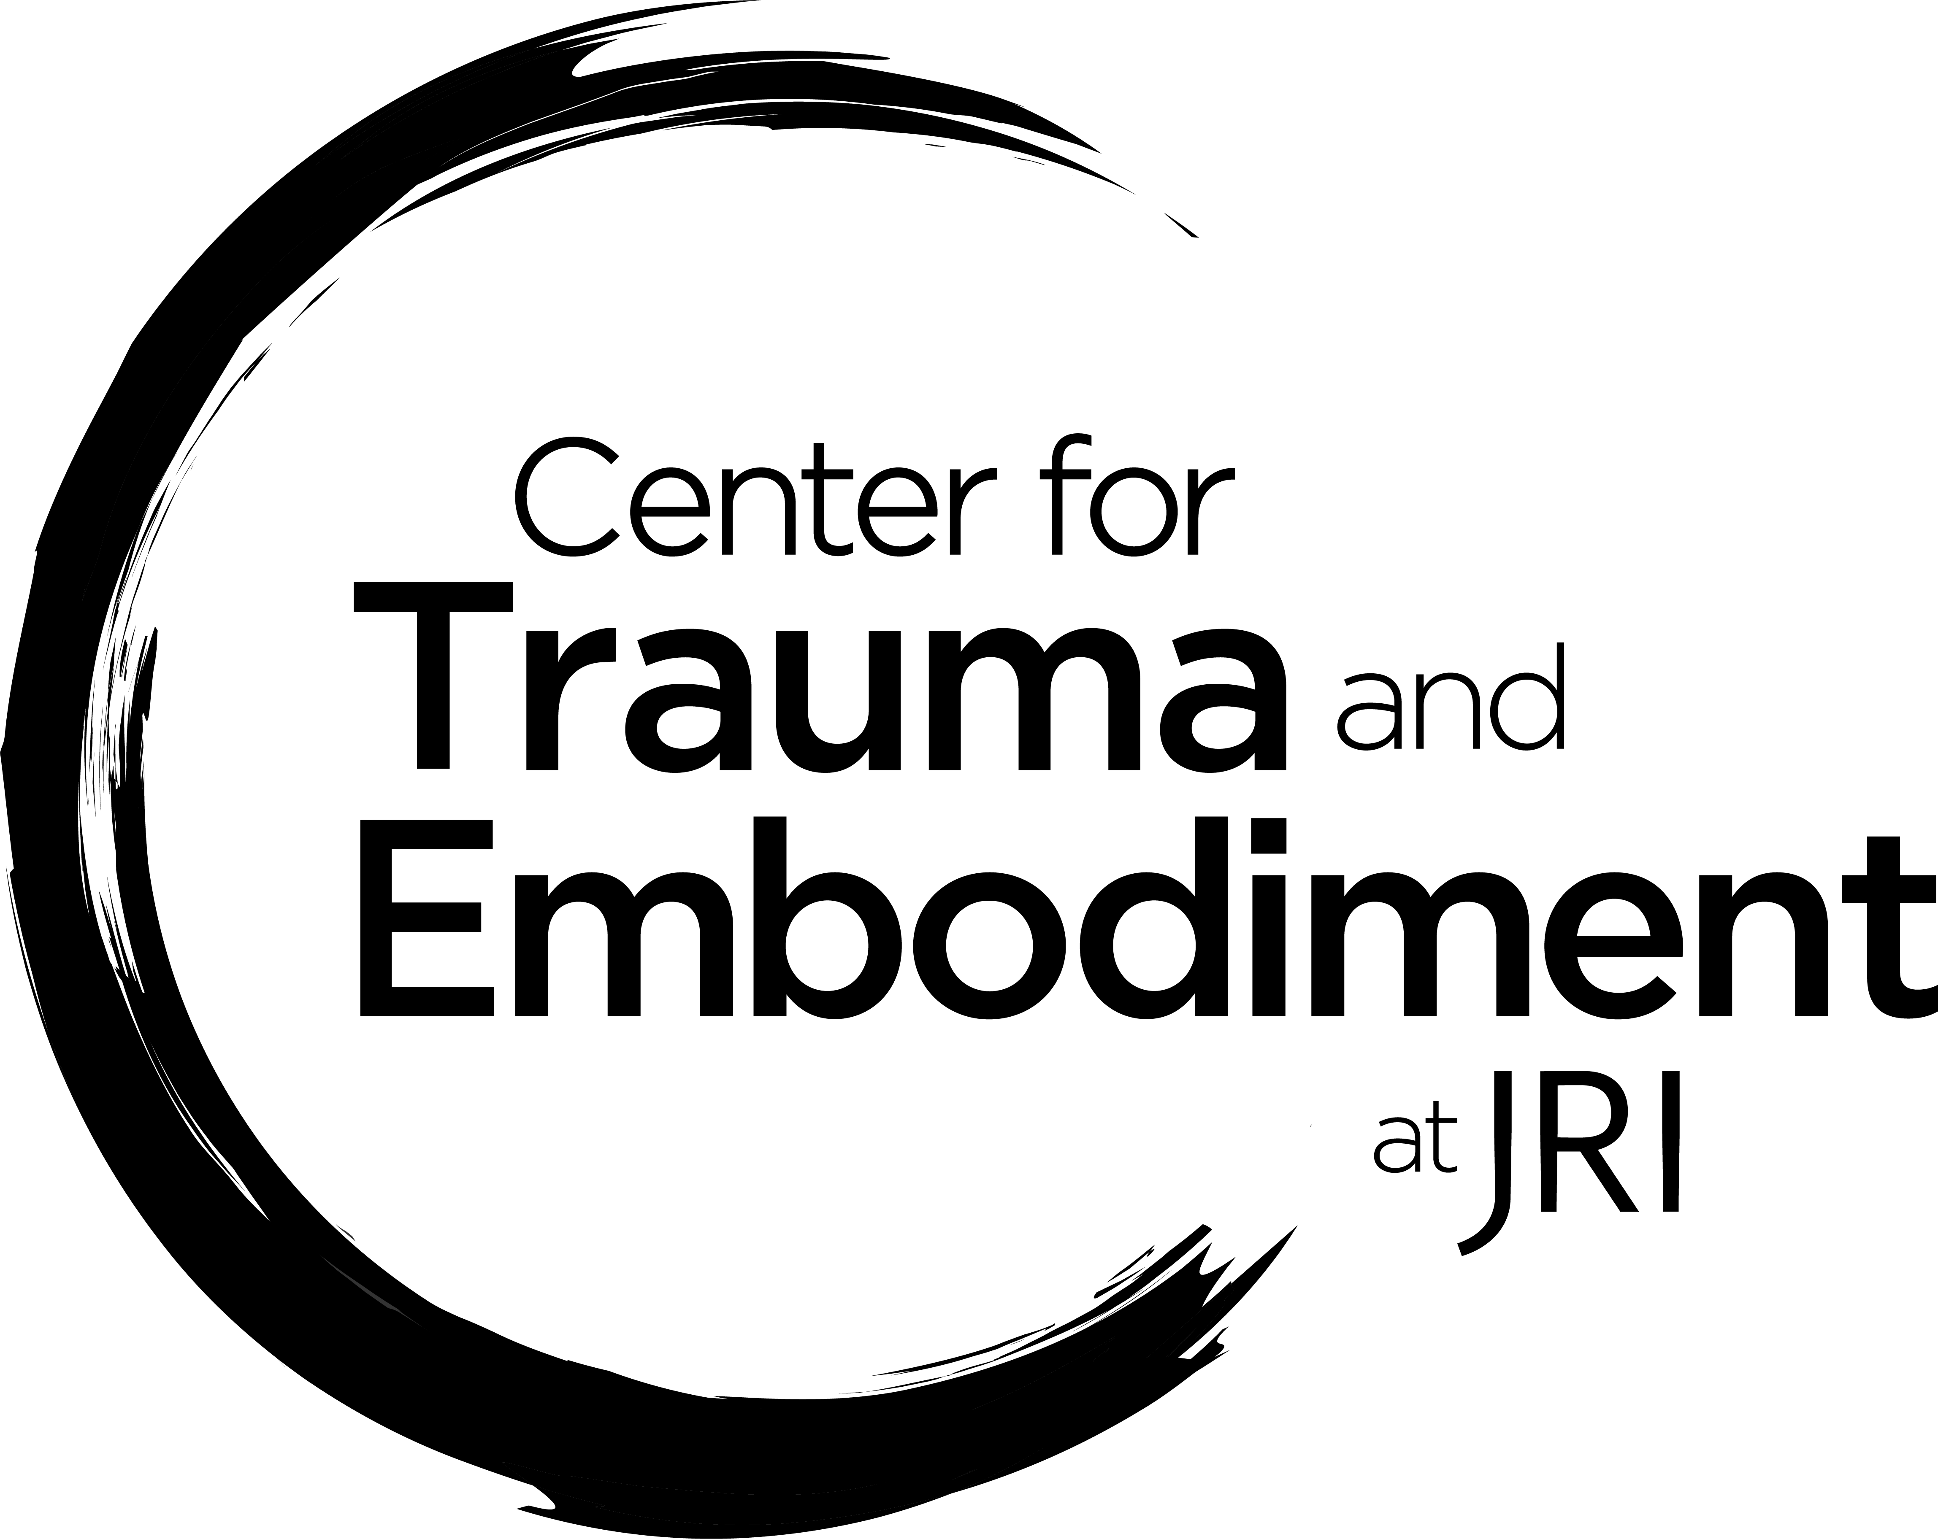

Trauma Center Trauma-Sensitive Yoga (TCTSY)Basic Information Sheet

What is TCTSY?

An adjunctive treatment for complex trauma that focuses on giving clients an opportunity to practice noticing body sensation (interoception) in the context of a safe relationship based on an invitational approach to yoga forms with no physical assists. TCTSY has been studied in several Randomized Controlled Trials and other research frameworks and has shown encouraging results, especially for people with early life, relational trauma (chronic physical, sexual emotional abuse and/or neglect).

What to expect:

- TCTSY has been designed to be a part of treatment for complex, inter-relational trauma - though you don't have to be receiving additional psychological care to practice TCTSY.
- We do recommend that you identify a supportive person or persons in your life that you can talk with about your experiences with TCTSY if you discover that would be helpful.
- You will not be asked or expected to talk about your trauma history as part of TCTSY.
- The focus is on noticing what you feel in your body (this is called “interoception”) and practicing making choices about what to do with your body based on what you feel. You will never be told what to do with the forms but rather invited to engage with the forms, as you like.
- To find more details about TCTSY including research papers please visit www.traumasensitiveyoga.com

